Assignment 5
Web technology
Ajay sahu

Que.1 Write a php program for the Form validation along with HTML Forms

Ans: First we will create Index.html file where we will write the code to create
the form.
Index.html --->
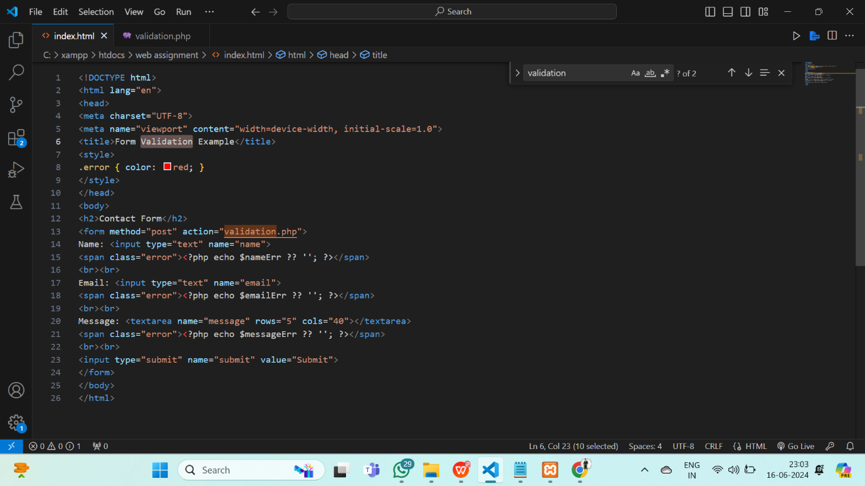

For Server side Validations We will create a file named validation.php
Server side validation code :
